# OWASP 08 – Insecure Deserialization

*Note: Current version will not allow for simple cookie decoding. A large portion of development was spent on attempting to modifying the main code to allow for cookies that could be easily decoded. It was not until the near the end of development that it would be a better solution to rewrite the code and implement a new module for handling cookies that do not require a secret key. This will need to be implemented in the next iteration*

### Walkthrough – Banking App

1. Create a new account or log into any account that is not the admin account.
2. Right-click the web browser and select inspect
3. Select the memory tab on the new panel
4. Expand the cookies option  
   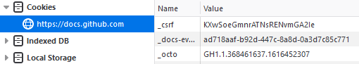
5. From there select the cookie for the exercise application
6. Run the cookie through a base64 decode to see the values stored
7. Modify the the value for the role_id to be 0
8. Run the new value through the base64 encoder
9. Go back to the cookie menu and right-click the cookie and enter the new encoded cookie
10. Select the Config tab from the home menu

### Exercises – Banking App

1. Modify the Shopping application to prevent the user from moving out of the profile picture directory to have a more difficult cookie to decode
2. Optional: implement a check that reconfirms the user’s cookie is unmodified